ESCALANTE CITY
P.O. BOX 189 ESCALANTE, UT 84726
P: 435.826.4644 F: 435.826.4642
APPLICATION FOR RIGHT OF WAY ENCROACHIWENT PERMIT (WORK CANNOT BEGIN UNTIL PERWT IS APPROVED)
Date 20

To: Escalante City
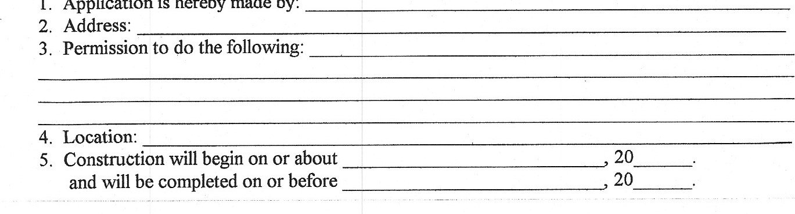
1.
Application
is
hereby
made
by:
New underground utility installation crossing road must be placed by boring. If boring is impossible due to unusual circumstances such as soil conditions, existing utilities, etc., a request for an exception may be made to the Mayor or City Council and the following information provided:
- Type of pavement
- Excavation will be ft long by ft wide and ft deep.
- A bond in the amount of $ has been posted with Telephone to run for a term of three (3) years after completion of work to guarantee satisfactory performance.
If this permit is granted, we agree to comply will all conditions, restrictions and regulations required by the City.

Owner
Signature/Title
To be filled in by the Public Works Director: Permit [ ] should [ ] should not be granted.
Special limitations: ___________________________________________________________
_________________________________________________________________________

_______________________________________
Public Works Director
(Refer to instructions on the back)

INSTRUCTIONS
- Application for this permit should be made by whoever will actually do the work, whether it be the owner or a contractor.
- Mailing address of applicant.
- State fully and completely the type of installation, type of construction, width, thickness, drainage data, etc. where applicable.
If a pole line, giving the following information: number of poles, total length of line, type of wire, character of service, vertical clearance over the roadway, and voltage if power line.
If a pipe line or buried cable, give the following information: type of service, size, and length of line, depth of trench, kind of pipe (sewer, gas, oil, water supply, etc.) or conduit. All transverse underground utilities must be placed under the pavement by boring. All fluid lines require encasement with suitable material. The size and length of encasement shall be satisfactory to Escalante City.
- Give distance from geographical point such as intersecting highways, and city limits.
- Attach two (2) copies of a plan showing proposed locations of structures with references to pavement and right of way lines. If installation crosses the highway, show cross section of present roadway and proposed installation. Identify the location of other utilities that may be in conflict.
- Give anticipated dates for beginning and for completion of proposed installations.
NOTE: A fee of twenty dollars ($20) will be charged for all Right of Way Encroachment Permits, This permit fee shall be submitted with the application.

